 | Curriculum Vitae | 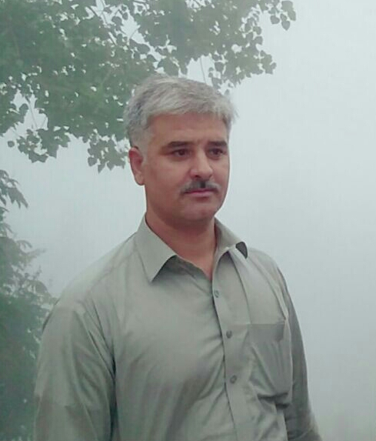
Syed Ghias Ali
(Horticulturist)
Centre of Plant Biodiversity, University of Peshawar, Khyber Pakhtunkhwa,
Peshawar 25120, Pakistan, Phone: 92-91-9218291; 0301-8823024
E-mail: ghiascpb@uop.edu.pk
_____________________________________________________________

Personal information

Born: September 15, 1980 in Village Utmanzai, District Charsadda, Khyber Pakhtunkhwa, Pakistan
Home address: 206, Professor Colony, near Agriculture University Peshawar, Khyber Pakhtunkhwa, Pakistan.
Nationality: Pakistani
Marital Status: Married

Languages

Pushto: Native speaker
English: Fluent (can speak, read and write)
Urdu: Fluent (can speak, read and write)
_____________________________________________________________
Qualification

- PhD in Horticulture (Horticultural Crops Stress Physiology) Department of Horticulture, The University of Agriculture Peshawar – Pakistan (December, 2015).

- Dissertation: Response of Tomato to Salinity and Drought Stress.

- M.Sc. (Hons) in Horticulture: CGPA= 3.86/4.00, securing 86.91% marks from Department of Horticulture, The University of Agriculture Peshawar – Pakistan (March, 2006).
Thesis: Physiological and Biochemical Responces of Tomato Cultivars to Salt Stress.
- B.Sc. (Hons) in Horticulture: CGPA= 3.06/4.00, securing 69.72% marks from Department of Horticulture, The University of Agriculture Peshawar – Pakistan (January, 2004).

Review Paper: Medicinal value of Horticultural Plants
Special Problem: Effect of fruit borer on the keeping quality and shelf life of tomato fruit.

- Intermediate Education:

  - F.Sc. (Pre-Medical), 2nd Division (From Board of Intermediate and Secondary Education Peshawar, Khyber Pakhtunkhwa, Pakistan in 1999)

- High School Education:

  - S.S.C. (Science Group), 1st Division (From Board of Intermediate and Secondary Education Peshawar, Khyber Pakhtunkhwa, Pakistan in 1997)
_____________________________________________________________
Professional Experience

- Working as Assistant Professor of Horticulture at Centre of Plant Biodiversity, University of Peshawar.

- Horticulturist cum Lecturer, Centre of Plant Biodiversity & Botanical Garden, University of Peshawar w.e.f. 12-09-2009 to 03-10-2016.

- Research Officer (BPS-17), in Agriculture Research System, Khyber Pakhtunkhwa, Pakistan since 04-06-2007 to 30-06-2009.

- Research Fellow in the HEC Funded project entitled “Evaluation and Control of Post Harvest Losses in Colocasia” from November 2005 to May 2007.
____________________________________________________________
Publications and Trainings
- Participating and organized different workshops on national level.
- Published five Research Paper in national and international repute journals and four are submitted and near to be published in the same journals.

